Restore a DB to SSMS

Steps

Delete a DB – tick Close existing connections tickbox

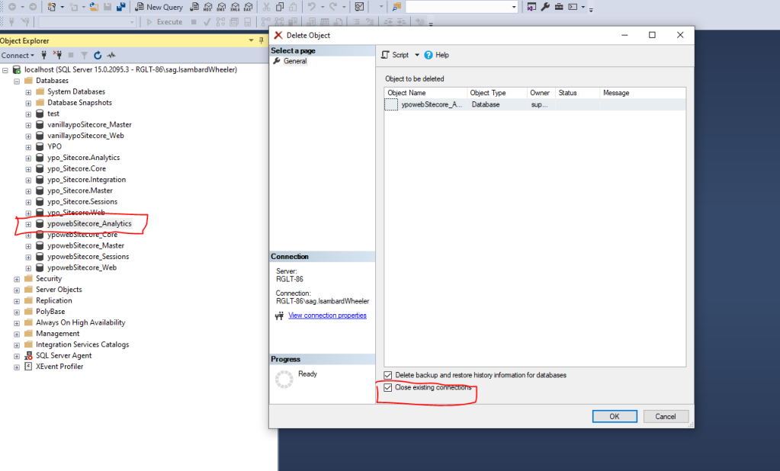

Right-click Database -> Restore Database

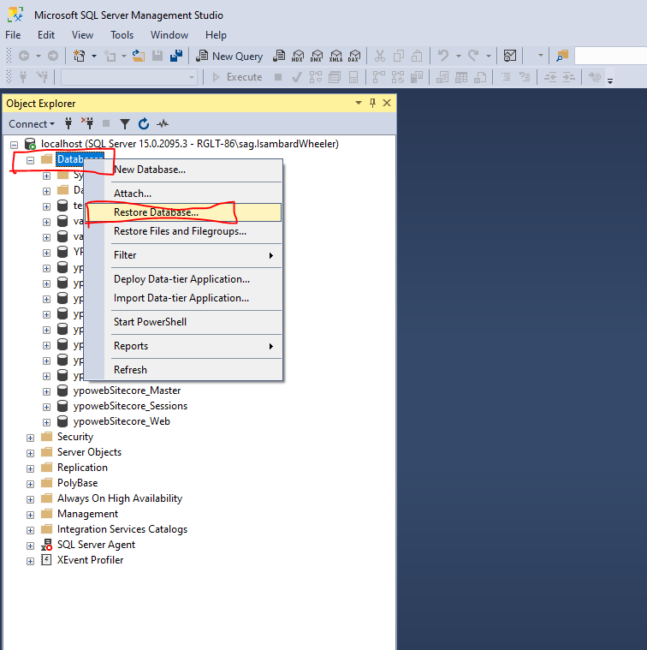

General -> Device -> Local machine

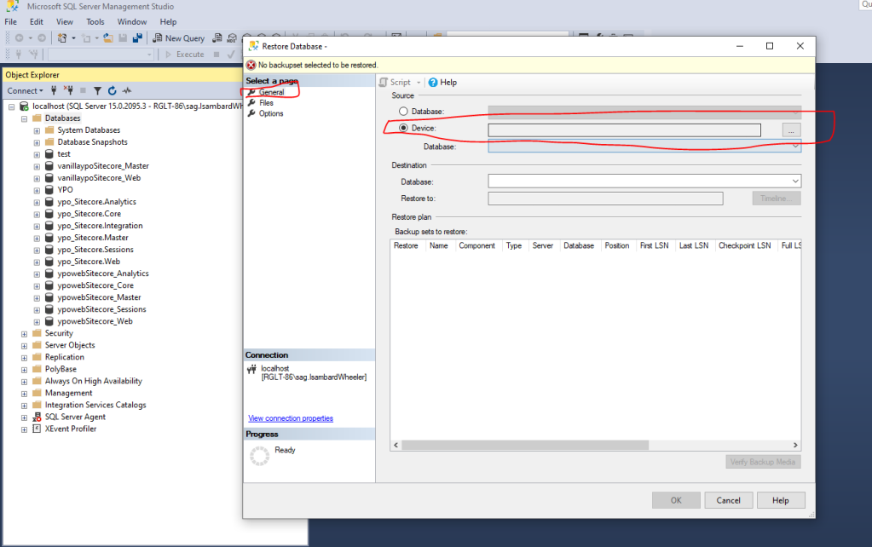

Click add

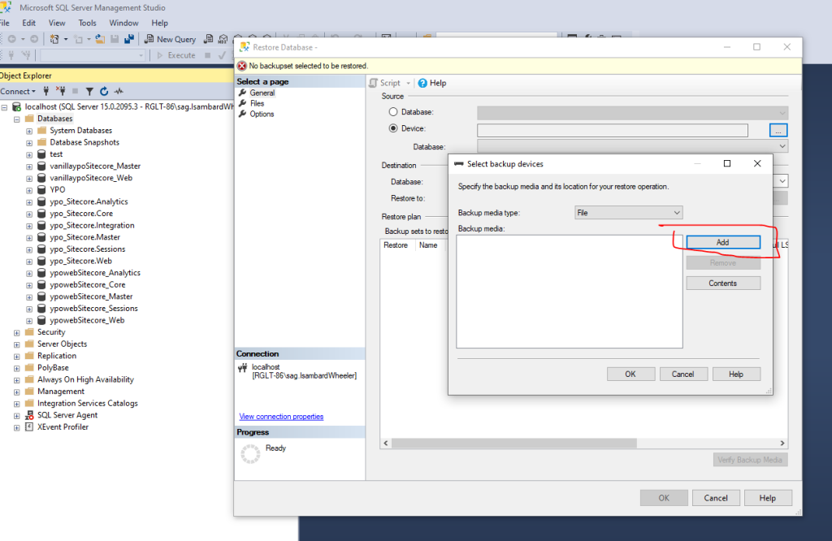

Change drop-down to All files

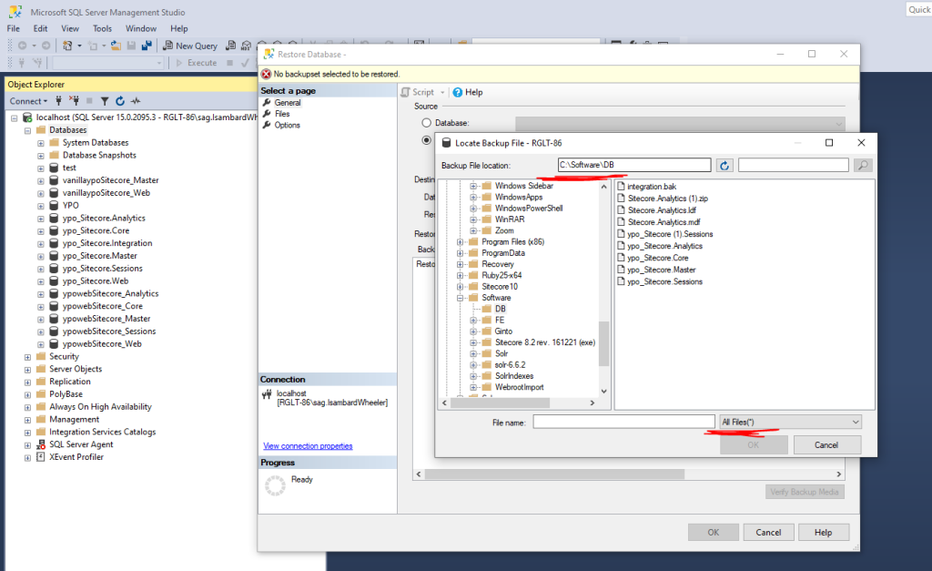

Click Ok to complete import

You can change the Destination -> database name if required.

